**Worksheet-1.4**

**Student Name:-** Pushpraj Roy **UID:-** 20BCS9866

**Branch:-** BE- CSE **Section/Group:-** WM_617 “A”

**Subject Code:-** 20CSP-338 **Semester:-** 5th

**Subject Name:-** Web and Mobile Security Lab

# Aim/Overview of the practical:

Working of SQL injection attack.

1. **Objective:** SQL Injection Attack from command line (url).

# Theory:

[SQL Injection (SQLi)](https://www.invicti.com/learn/sql-injection-sqli/) is a type of an [injection attack](https://www.acunetix.com/blog/articles/injection-attacks/) that makes it possible to execute malicious SQL statements.

These statements control a database server behind a web application. Attackers can use SQL Injection vulnerabilities to bypass application security measures.

They can go around authentication and authorization of a web page or web application and retrieve the content of the entire SQL database.

They can also use SQL Injection to add, modify, and delete records in the database.

In some database servers, you can access the operating system using the database server. This may be intentional or accidental.

In such case, an attacker could use an SQL Injection as the initial vector and then attack the internal network behind a firewall.

# Source Code and Output:

Open demo.testfire.net login Page -

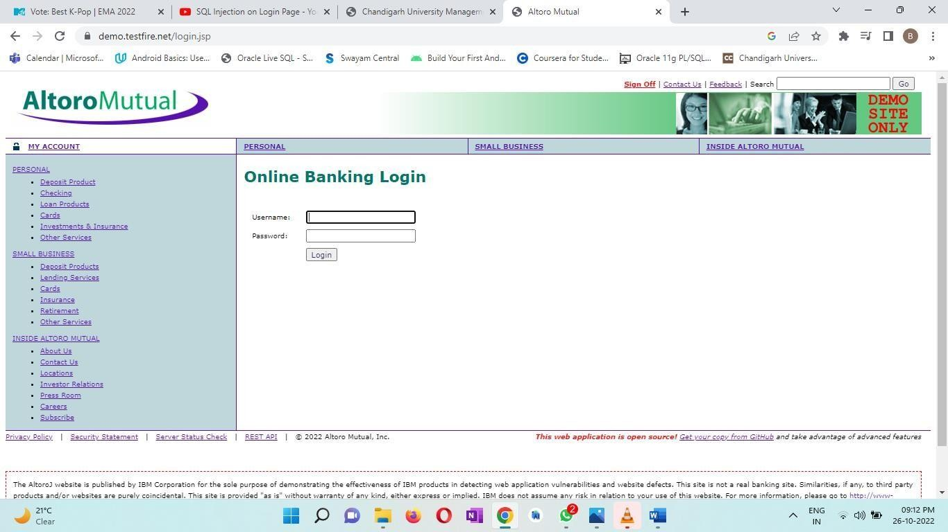

Enter the username and password, shown below –

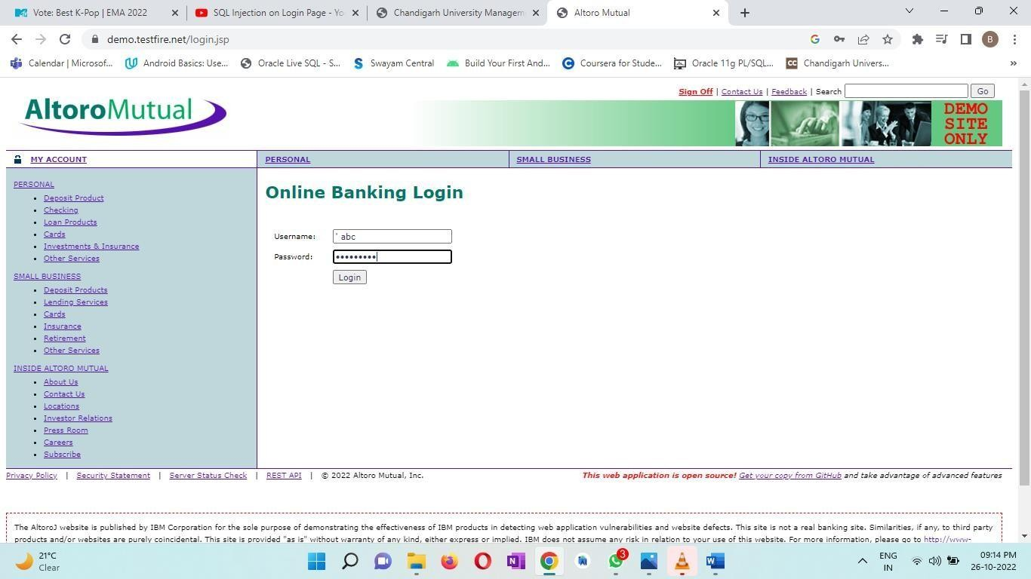

The output shows error –

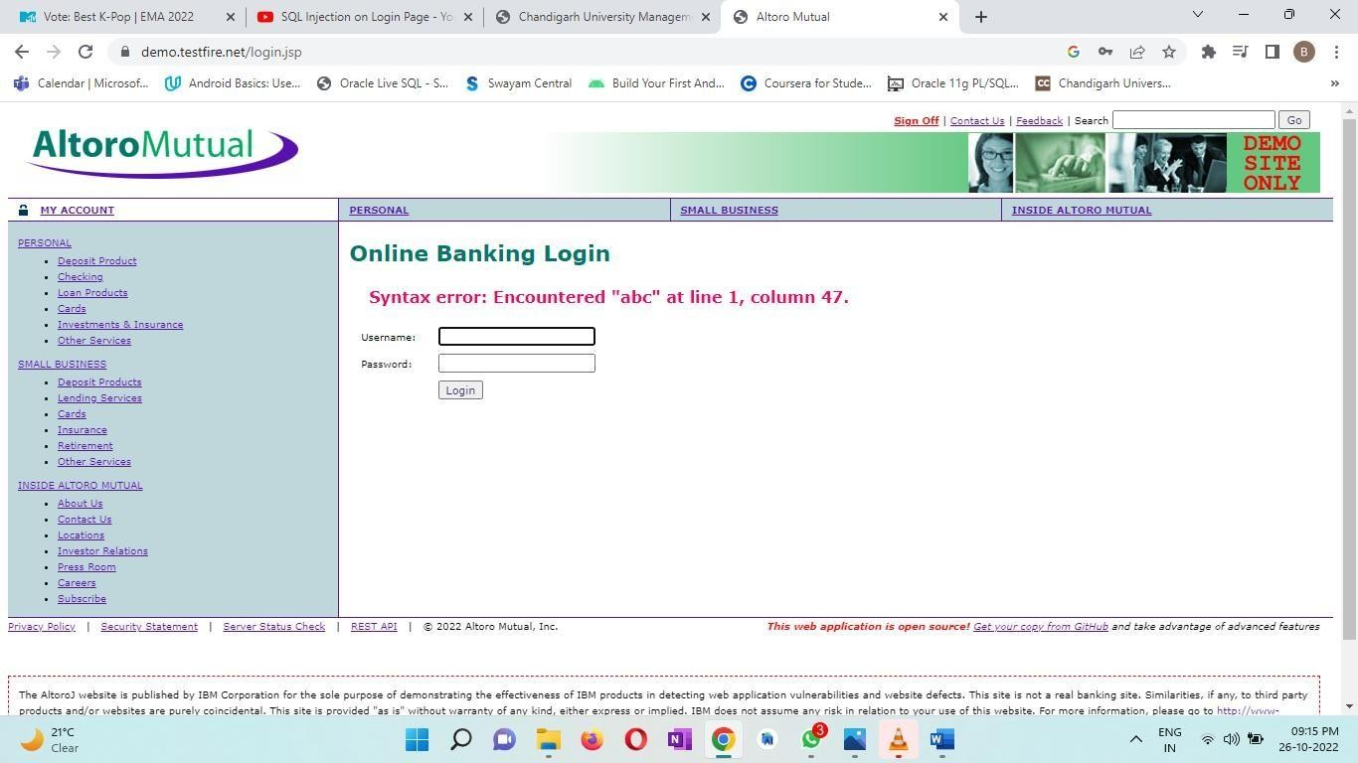

Enter the username and password again –

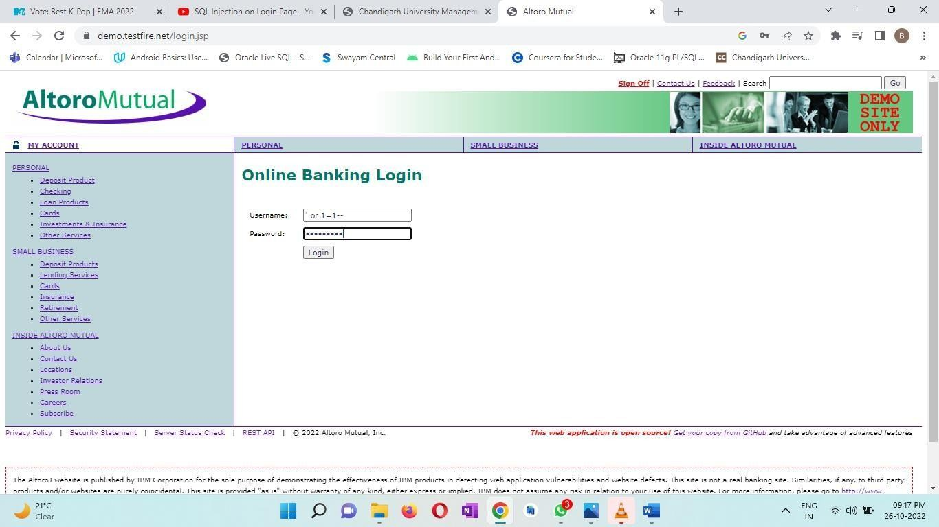

The output is shown below –

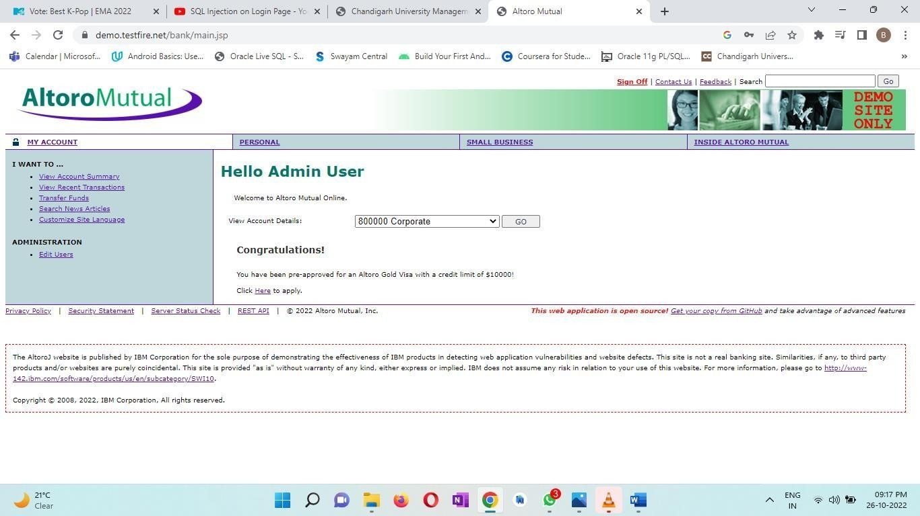

If we click on Go, following interface will open –

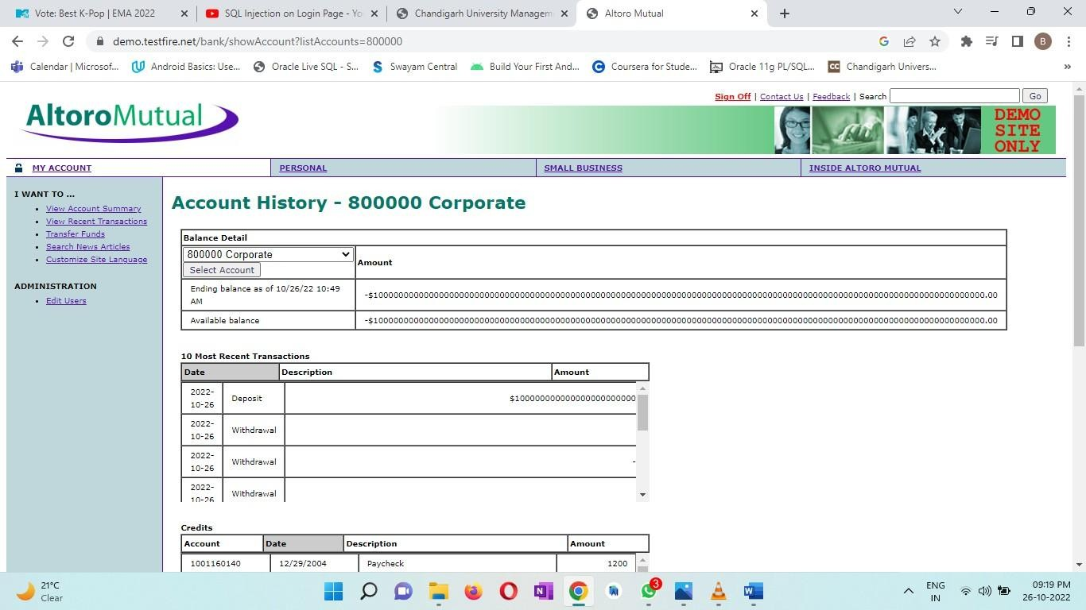

# Learning outcomes (What I have learnt):

* 1. Attackers can use SQL Injections to find the credentials of other users in the database.
  2. They can then impersonate these users. The impersonated user may be a database administrator with all database privileges.
  3. An SQL Injection vulnerability could allow the attacker to gain complete access to all data in a database server.

# Evaluation Grid:

|  |  |  |  |
| --- | --- | --- | --- |
| **Sr. No.** | **Parameters** | **Marks Obtained** | **Maximum Marks** |
| **1.** | **Student Performance (Conduct of**  **experiment)**  **objectives/Outcomes.** |  | **12** |
| **2.** | **Viva Voce** |  | **10** |
| **3.** | **Submission of Work Sheet**  **(Record)** |  | **8** |
|  | **Total** |  | **30** |